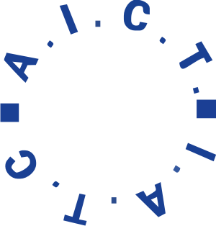

International Association of Theatre Critics
Workshop for Young Critics at the Tbilisi International Festival of Theatre
Tbilisi, Georgia, 16-20 September 2026

Application Form
Name:
Gender: Male/Female
Nationality:
Date of Birth:
E-mail:
Other contacts:

Which language do you prefer? French/English
Write down your language level in both languages:
French : B1 B2 C1 C2
English : B1 B2 C1 C2

Please indicate whether you have already completed the workshop or whether you have already applied previously for the workshop:

IATC-affiliated national/regional section recommending the young critic:

Short CV and main professional experience (newspaper, journal, radio/TV, web, blog…):

Attached samples from articles published or broadcast:

In case of a country without a national association of theatre critics, other recommendations:

